In 1831, Michael Faraday, an English physicist gave one of the most basic laws of electromagnetism called Faraday's law of electromagnetic induction. This law explains the working principle of most of the electrical motors, generators, electrical transformers and inductors. This law shows the relationship between electric circuit and magnetic field. Faraday performs an experiment with a magnet and coil. During this experiment, he found how emf is induced in the coil when flux linked with it changes. He has also done experiments in electro-chemistry and electrolysis.

**Faraday's Laws**

**Faraday's First Law**

Any change in the magnetic field of a coil of wire will cause an emf to be induced in the coil. This emf induced is called induced emf and if the conductor circuit is closed, the current will also circulate through the circuit and this current is called induced current.

**Faraday's Second Law**

It states that the magnitude of emf induced in the coil is equal to the rate of change of flux that linkages with the coil. The flux linkage of the coil is the product of number of turns in the coil and flux associated with the coil.

**Mathematical Representation of Faraday’s Law**

Consider a magnet approaching towards a coil. Here we consider two instants at time T1 and time T2.

Flux linkage with the coil at time, T1 = NΦ1 Wb

Flux linkage with the coil at time, T2 = NΦ2 wb

Change in flux linkage = N (Φ2 - Φ1)

Let this change in flux linkage be, ∆Φ = Φ2 - Φ1

So, the Change in flux linkage = N∆Φ

Now the rate of change of flux linkage = N∆Φ / ∆t

Take derivative on right hand side we will get

The rate of change of flux linkage = NdΦ/dt

But according to Faraday's law of electromagnetic induction, the rate of change of flux linkage is equal to induced emf.

**Lenz's Law**

Lenz’s law states that the [direction](http://www.oxforddictionaries.com/definition/english/direction#direction__4) of an [induced](http://www.oxforddictionaries.com/definition/english/induce#induce__13) [current](http://www.oxforddictionaries.com/definition/english/current#current__7) is always such as to [oppose](http://www.oxforddictionaries.com/definition/english/oppose#oppose__3) the [change](http://www.oxforddictionaries.com/definition/english/change#change__22) in the circuit or the [magnetic field](http://www.oxforddictionaries.com/definition/english/magnetic-field#magnetic-field__3) that produces it.

So, induced emf = - NdΦ/dt

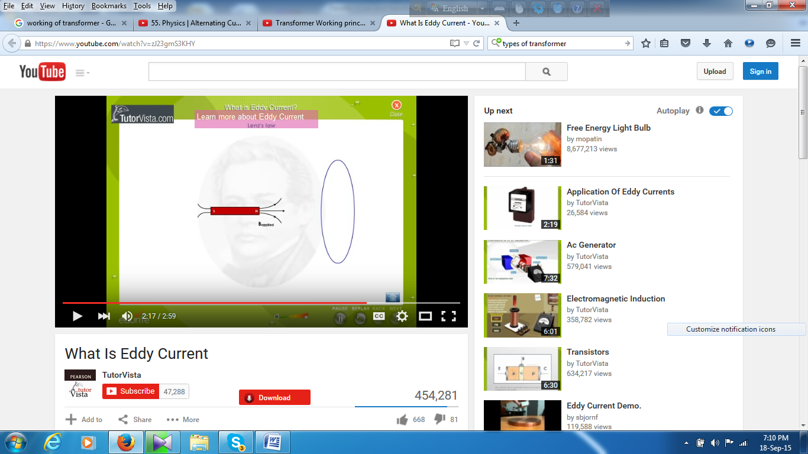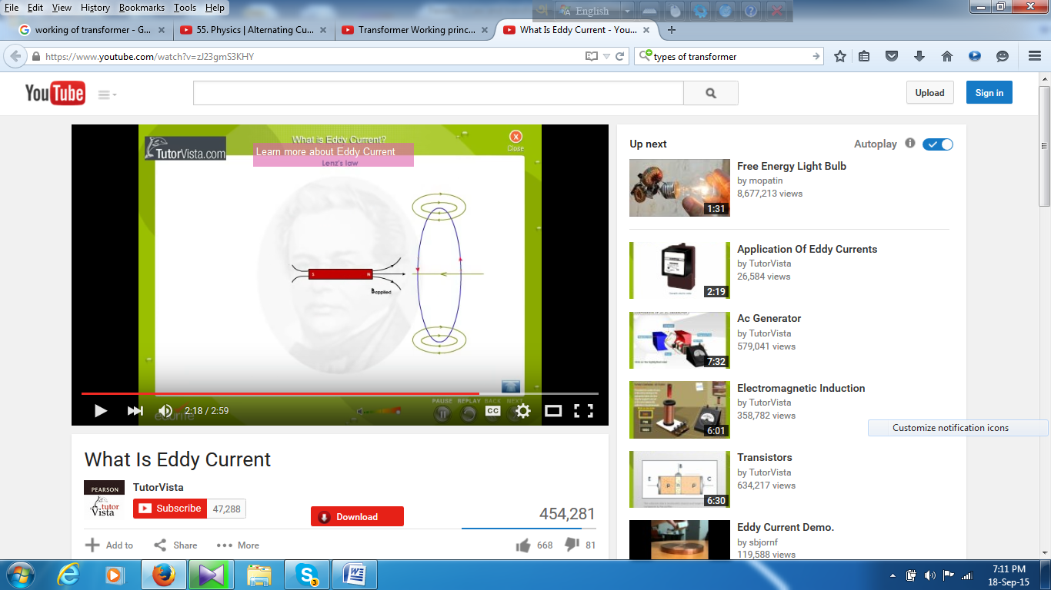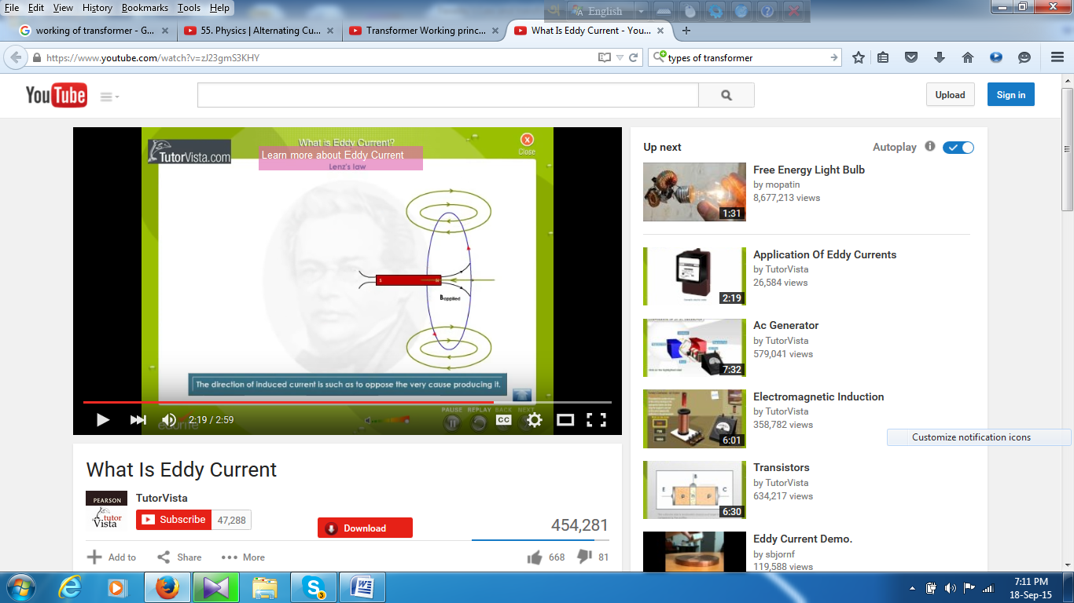

**Applications of Faraday Law**

Faraday law is one of the most basic and important laws of electromagnetism. This law finds its application in most of the electrical machines, industries and medical field etc.

•Electrical Transformers

•Electrical Generators

•Induction Cookers

•Electromagnetic Flow Meters

•Form the bases of Electromagnetic Theory

•Musical Instruments

**Fleming’s Right Hand Rule:** Stretch the forefinger, the middle finger and the thumb of the right hand, such that they are mutually perpendicular to each other. If the forefinger indicates the direction of the magnetic field, the thumb indicates the direction of motion of the conductor, and then the middle finger indicates the direction of induced current in the conductor.

### ****Transformer – Working Principle****

A transformer can be defined as a static device which helps in the transformation of electric power in one circuit to electric power of the same frequency in another circuit. The voltage can be raised or lowered in a circuit, but with a proportional increase or decrease in the current ratings.

The main principle of operation of a transformer is mutual inductance between two circuits which is linked by a common magnetic flux.

## 

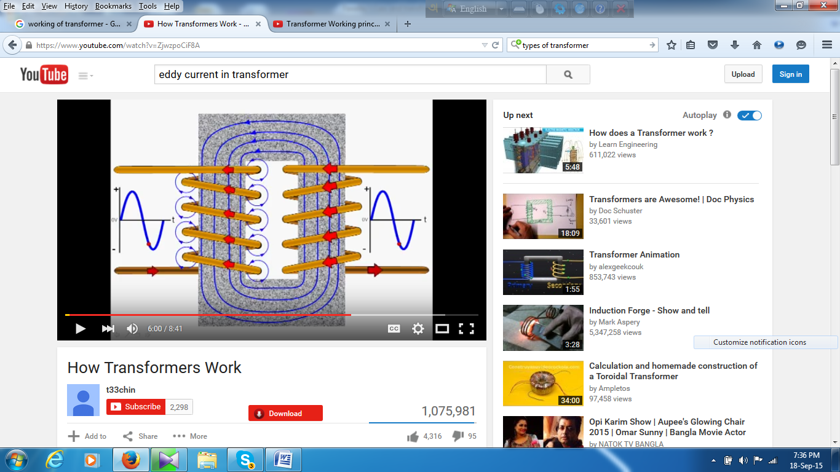

## Transformer Construction

The construction of a simple two-winding transformer consists of each winding being wound on a separate limb or core of the soft iron form which provides the necessary magnetic circuit. This magnetic circuit, know more commonly as the “transformer core” is designed to provide a path for the magnetic field to flow around, which is necessary for induction of the voltage between the two windings.

**Types of Transformer:**

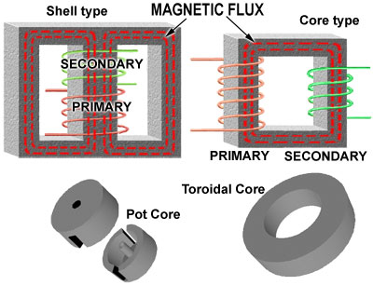

**Eddy Current:**

Eddy currents (also called Foucault currents) are circular [electric currents](https://en.wikipedia.org/wiki/Electric_current) induced within [conductors](https://en.wikipedia.org/wiki/Conductor_%28material%29) by a changing [magnetic field](https://en.wikipedia.org/wiki/Magnetic_field) in the conductor, due to [Faraday's law of induction](https://en.wikipedia.org/wiki/Faraday%27s_law_of_induction). Eddy currents flow in closed loops within conductors, in planes perpendicular to the magnetic field.

